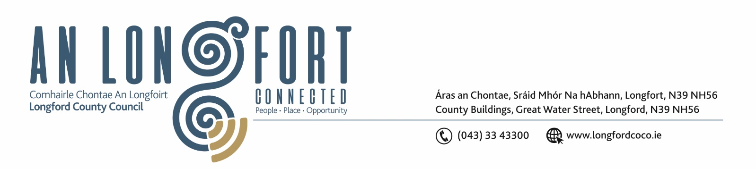

5u Mi na Nollag 2019.

Chuig: Gach Ball don Chomhairle.

A Chomhairleoir,

Iarrtar ort bheith i láthair ag Cruinniú Chomhairle Chontae Longfoirt a tionólfar i Seomra na Comhairle, Aras an Chontae, Longford ar an Chéadaoin, 11u Mi na Nollag 2019 ag 3.00 p.m chun gnó a dhéanamh d’réir an Chláir thíos.

You are requested to attend Meeting of Longford County Council to be held in the Council Chamber, Aras an Chontae, Great Water Street, Longford on Wednesday, 11th December 2019 at 3.00 p.m. to transact business, as set out on the Agenda hereunder.

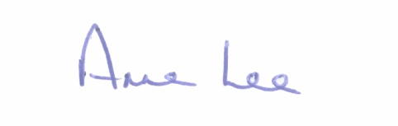
Mise le meas,

__________________
Anne Lee,
Meetings Administrator.

C L A R

Prayer before meeting.

- Confirmation of Minutes of the meeting of Longford County Council held on 9th October 2019
– copy enclosed.

- Matters arising from Minutes.

3. Declaration of Interest by Members.

4. To note Management Report - to follow.

5. Strategic Infrastructure and Climate Change.

- To note Planning Applications received since last meeting of the Council.

(b) Consideration of disposal of Freehold Interest of property at Deanscurragh, Longford to
Mr. Patrick Byrne in accordance with the terms of Section 183 of the Local Government Act 2001, circulated on the 20th November 2019.

- Notices of Motions submitted by Councillor Councillors, as listed hereunder –
Councillor Gerry Warnock.
“I am calling on Pascal Donohoe, Minister for Finance, to consider an amendment to the “Help to Buy Scheme for First Time Buyers” to make provision to qualify First Time Buyers who wish to purchase and renovate existing residential units. Under the current scheme First Time Buyers only qualify if they purchase new builds or build directly. This precludes a substantial body of potential buyers who may wish to look at existing properties as opposed to the former. Considering that there were in excess of 200k vacant properties recorded during the 2016 Census, such incentivisation might encourage a greater swing towards the purchasing and renovation of vacant stock, at greater value to the buyer, thus contributing to the easing of the housing/rental crisis. I am asking that this motion, if successfully moved, be circulated to all the other Local Authorities.”
“I am calling on Longford County Council to make a formal policy commitment, that at least 60% of future turnkey housing developments purchased by the Local Authority will be made available as Affordable Housing options for working families who do not qualify for Housing Supports under current guidelines. Such a measure would go somewhat towards mitigating an overabundance of social housing already in the county, while providing housing opportunity for a large section of our community who also need consideration from State Agencies. I am hoping, that if supported by the Members, that we contact the Minister, and An Taoiseach, DIRECTLY with this proposal and seek letters of approval for this measure, while outlining the ACTUAL Housing need within the County i.e. The Need for Affordable rather than Social Housing.”

Councillor Paul Ross.
“That Longford County Council provides reverse vending machines in every town and village in Longford to encourage the recycling of plastic bottles in the County.”

Councillor Turlough McGovern.
"That extra supply of sand and salt be available to grit secondary and local tertiary roads as we all know climate change has made our winters colder and driving conditions dangerous.
I think that we should at least try to do this so people can get to work and children can get to school safely on these roads."

6. Community, Corporate and Enterprise.

- Consideration and adoption of Draft Corporate Plan 2019 – 2024 – to follow.

- Consideration and adoption of Draft Strategic Policy Committee Scheme 2019 – 2024
enclosed.

(c) To fix date for January 2020 Meeting of Longford County Council.

(d) (i) Political Donations - Local Elections (Disclosure of Donations
and Expenditure ) Act 1999, as amended - Members of Local Authorities.

(ii) Political Donations - Local Elections (Disclosure of Donation
and Expenditure ) Act 1999, as amended - Third Parties.
(Guidelines and form(s) to be circulated )

(e) Consideration of Request from Councillor Micheal Carrigy, Cathaoirleach – referred from
November Corporate Policy Group Meeting -
“I call on Longford County Council to host a Civic Reception for County Longford Community Games in their 50th Year, to recognise their contribution to the youth in our County and to recognise the Gold Medal winners in 2019.

(f) Appointment of Mr Sean Donohoe, nominee of Granard Traders Association, to replace Mr. Oliver Cassidy as a member of Longford Local Community Development Committee (LCDC).

(g) Appointment of Mr. James Belton to represent the farming/agricultural community in Longford on the Longford Joint Policing Committee.

7. Finance & Regeneration.

(a) Section 142 (5) (F) of the Local Government Act 2001 -
Requirement for elected members to submit a summary of proceedings to Council meetings
following from meetings/events/training attended by members – form for completion attached.

(b) Notices of Motions submitted by Councillor Micheal Carrigy.

“I call on Longford County County Council to support the National Broadband Plan.”

“I call on Longford County Council’s Insurers, Irish Pubic Bodies, to provide insurance to the community groups in County Longford who have difficulty securing insurance cover.”

8. General.

- Notices of Motions, submitted by Councillors, as listed hereunder –

Councillor Micheal Carrigy.

“I call on Longford County Council to support the right to PAS – Personal Assistance Service for disabled people to have freedom, choice and control over all aspects of their lives to enable them to fully participate in an inclusive society as equals.”

Councillor Paul Ross.

“That all farmers selected for Single Farm Payment inspections be paid their advance payments in October and any financial discipline which may apply following inspection be then taken from the second balance.”

- Correspondence - enclosed

- Letter dated 8th October 2019 received from the Minister for Defence regarding
issue the 33 Distinguished Service Medals to the heroes of the Jadotville Siege.
- Letter dated 9th October 2019 received from the Office of the Minister for Housing, Planning and Local Government regarding the provision of affordable housing in Longford.
- Letter dated 29th October 2019 received from the Office of Garda Commissioner regarding request to attend Joint Policing Committee meeting.
- Letter dated 26th November 2019 received from the Office of the Minister for Communications, Climate Action & Environment regarding National Clean Air Strategy.

9. Votes of sympathy.

10. Training -
Consideration of Report from Corporate Policy Group.



